**FLYING FINN**

**7503 LEVANDER RD**

**EMBARRASS, MN 55732**

**MAY 2023**

**ISSUE #382**

**Welcome Spring Pancake Breakfast**

**Saturday, May 6**

8 to 11 am

Timber Hall

4855 Highway 21, Embarrass

**Local Board of Appeal & Equalization**

**Wednesday, May 2, 2023 – 6:00 pm**

**EMBARRASS TOWN HALL**

**Road side clean up May 1st – June 17th.**

**Embarrass Town Board Meeting**

**Wednesday, MAY 10, 2023**

**@ 6:00 p.m.**

Please submit materials for the June 2023 issue to the Embarrass Clerk’s Office by May 18, 2023

**MEMORIAL DAY SERVICE EMBARRASS CEMETERY**

**MAY 29 – 9:00 A.M.**

|  |  |  |  |  |  |  |
| --- | --- | --- | --- | --- | --- | --- |
| **MAY 2023** | | | | | | |
|  | 1 | 2  Ladies Coffee  LBAE 6:00 – 7:00  @ Town Hall | 3 | 4  Conversational Finn 1-3 p.m | 5 | 6  Pancake Breakfast & Blood Drive  Timber Hall  8-11 |
| 7    4 Corners 4-H  4 p.m. | 8 | 9  Ladies Coffee  .  Embarrass Region Fair Association  Timber Hall  Strategic  Planning Committee  6:00 p.m. | 10  Township Board Meeting  6:00 p.m. | *11*  Conversational Finn 1-3 p.m | 12 | 13 |
|  |  |  |  |  |  |
|  | |  | |  |  |  |
| 14  MOTHERS  DAY | 15  SISU Meeting 6:30 p.m. | 16  Ladies Coffee | 17  Town Board  Property & Road Inspection | 18  Conversational Finn 1-3 p.m  Embarrass Region  Fair Association Mtg.6:30 p.m.  Timber Hall | 19 | 20 |
| 21 | 22 | 23 | 24 | 25 | 26 | 27 |
|  |  |  |  |  |  |
|  |  | Ladies Coffee |  | Conversational Finn 1-3 p.m |  |
|  |  |  |  |  |  |
|  |  |  |  |  |  |
| 28 | 29  Memorial Service 9:00 a.m. Embarrass Cemetery | 30  Ladies Coffee | 31 |  |  |  |

FROM THE EDITOR: The Flying Finn strives to represent both Embarrass and the surrounding area. To submit articles, advertisements, community notices, letters to the editor, photos, artwork, etc. for the newsletter, mail them to Embarrass Town Hall, 7503 Levander Rd, Embarrass, MN 55732, or e-mail them to [embarrasstownship@frontiernet.net.](mailto:embarrasstownship@frontiernet.net) Please include your name, phone number and e-mail address. Photos or other materials will be returned as soon as possible. The township regrets that it is unable to purchase or reimburse for materials which are published. The Town of Embarrass reserves the right to publish or not publish any letter to the editor or other submitted material. Call 218-984-2084 with any questions. ***** Thank you. Diane Nelmark, Editor

Town of Embarrass

Regular Board Meeting

April 12, 2023

PENDING BOARD APPROVAL

Visitors: Eric Garman, Bill Wright, Roland Fowler

Present: Jack LaMar, Alyssa Hammond, Shireen Lee, Jennifer Boese, Mary Novak

Meeting called to order by LaMar with the Pledge of Allegiance at 6:05 p.m.

*Motion/Lee: Second/Hammond approve the March 2023 minutes. Carried 3-0.*

Treasurers Report reviewed. *Motion/LaMar: Second/Hammond to transfer $8000 from the Historic Property Fund and $7000 from the Capital Fund to the General Fund, when tax apportionment is deposited the funds to be put back. Carried 3-0.*

Eric Garman speaks to the Town Board Supervisors to show his interest in becoming Cemetery Sexton. *Motion/LaMar: Second/Hammond to accept Garman as Cemetery Sexton. Carried 3-0.*

Maintenance Report. Regular daily maintenance. Leaking at the Town Hall, the roof was cleared of ice and snow. Snow removal from properties. John Deere was serviced. Pumping of holding tank at Post Office by A1 after alarm went off. Employee has taken another job opportunity. *Motion/Hammond: Second/Lee to post for 6-week maintenance position, post position until June 1st. Carried 3-0*

Campground Hosts will be returning as early as the first week in May if the weather permits. Reservations taken by the clerk have been steadily coming in throughout the winter months for the upcoming season. *Motion/Lee: Second/Hammond to increase campground host monthly wage to $350. Carried 3-0.* Water filters are to be replaced at least once a month and chlorine tablets added.

*Motion/Lamar: Second/Hammond to approve the Liquor License Renewal for Trapline. Carried 3-0.* Clerk signs renewal form and returns to Trapline.

Quilting Club inquiring about the use of the town hall. Supervisors in favor if does not interrupt with previous reserved dates.

The Ad-HOC Committee letter regarding ambulance service was reviewed and discussed. The supervisors have questions and concerns. LaMar to follow up with the medical board.

The Property Inspection meeting will be held on May 17, 2023, at 3:00 p.m.

ERFA requesting of use of tables, chairs, and maintenance help *Motion/Lee: Second/ Hammond to grant the requests made by the Fair Board. Carried 3-0.*

Welcome package for new township residents discussed by Lee. Lee to continue with the information packets.

Cemetery Association was discussed. *Motion/Lee: Second/Hammond to work to form a Cemetery Association to help with organizing, cleaning, recommendations and more for the Embarrass Cemetery. Carried 3-0. Motion/Lee: Second/Hammond for Clerk to post for interested parties to contact the office or LaMar, do not have to be a resident to participate. Carried 3-0.*

Reminder of the upcoming LBAE meeting to be held on May 2nd, 6 p.m. -7 p.m. at the Embarrass Town Hall.

Roadside Cleanup in Embarrass will be from May 1st through June 17th.

Memorial Day Service at the Embarrass Cemetery will be held May 29TH.

*Claims and Correspondence reviewed and approved. Motion/Lamar: Second/Lee. Carried 3-0.*

*Meeting adjourned by LaMar at 8:35 p.m.*

Respectfully Submitted,

Jennifer Boese

**SPECIAL THANK YOU**

**to Wally O’Farrell for 20 plus**

**years serving as the Embarrass Township Cemetery Sexton. We thank you for your**

**hard work and dedication for so many years.**

**Enjoy your retirement!**

**Plans for a gathering to honor Wally are in**

**the works and will be held at a later date.**



**___________________________________________________________**

**Embarrass Township is looking for a temporary maintenance employee.**

Some of the maintenance responsibilities are:

Fulfill responsibilities set by the township board of supervisors, maintenance supervisor and clerk.

Coordinate and resolve work-related problems.

Mowing, raking, trimming, and clearing away brush of township properties.

Painting and repairing masonry or woodwork features of buildings.

Abide by all local, state, and federal safety and health laws.

Clean Town Hall, rest rooms, and other work and public areas

Transport garbage and waste to disposal area.

Replenish bathroom supplies, light bulbs, and other supplies.

Transport equipment and tools to work sites.  
Maintain equipment when needed.

Set up and take down tables & chairs at Town Hall.

**Job Descriptions are subject to change with different   
activities that the township is engaged in.**

Call or email the Embarrass Clerk’s Office At

(218)-984-2084 / [embarrasstownship@frontiernet.net](mailto:embarrasstownship@frontiernet.net)

Applications must be received by June 1st



**EMBARRASS ROADSIDE CLEANUP**

**May 1st – June 17th**

**\*Call Embarrass Town Hall 984-2084 to sign up to clean a specific road or location and to pick up garbage bags.**

Call 984-2084 when bags are ready to be picked up by the Maintenance Department.

THANK YOU FOR YOUR ASSISTANCE IN KEEPING EMBARRASSS BEAUTIFUL!



**OPENING SOON!**

**Heritage Park & Campground**

**(218)-410-7743 or (218)-984-2084**

**4789 Salo Road, Embarrass, MN 55732**

**Primitive (Tent)**

***1 Day - $20.00***

***2 Days - $40.00***

***3 Days - $60.00***

***4 Days - $80.00***

***5 Days - $90.00***

***6 Days - $95.00***

***1 Week - $100.00***

***1 Month - $350.00***

**RV Camper w/Water & Electric**

***1 Day - $30.00***

***2 Days - $60.00***

***3 Days - $90.00***

***4 Days - $120.00***

***5 Days - $150.00***

***6 Days - $170.00***

***1 Week - $180.00***

***1 Month - $600.00***

***Seasonal - $2,500***



#### ADS FOR LOCAL BUSINESSES

Suggested donation to The Flying Finn

1/4 Page = $10; 1/2 Page = $20;

Full Page = $40

To place an ad, write to:

*The Flying Finn, 7503 Levander Rd Embarrass MN 55732*

Email [embarrasstownship@frontiernet.net](mailto:embarrasstownship@frontiernet.net)

or call the Embarrass Town Clerk at

984- 2084.

#### SUBSCRIPTIONS

Persons interested in subscribing to The Flying Finn may drop off or send a donation of $20 for one year, payable to the Town of Embarrass, 7503 Levander Road, Embarrass, MN 55732.

The Flying Finn makes a great gift for someone who has moved out of the community!

The Flying Finn and the Town of Embarrass welcome announcements about community events and community groups. These submitted announcements are printed here and on following pages. Neither the Town of Embarrass nor The Flying Finn necessarily endorses the viewpoints or ideology of these groups or their events. The Town of Embarrass reserves the right to publish or not publish any letter to the editor or submitted material.

#### PIKE SANDY WOMEN’S CLUB

April 4, 2023, 7 p.m.

Pike Town Hall

At the April 4th meeting of the Pike Sandy Women's Club, Pike community member Jodi Backman was honored with a cake from the Township and board members for her 20 years of service as Township Clerk. Backman recently retired from her position.

Preparations continued for the Women's Club Public Bingo and Bake sale to be held April 19th, 2023, 6:30 to 8:30 p.m., at the Pike Town Hall.  The Bingo will include some special games and the final game will be a blackout game for two fifty-dollar Visa cards.

The next meeting of the Pike Sandy Women's Club will be hosting a Community Potluck Night expected to be May 2nd,2023, at the Pike Town Hall at 6p.m...Entertainment will be provided by the Hutter Bunch.

For any inquiries about the upcoming events or interest in Club membership, call Lynne Stuckey at 218-410-0167.

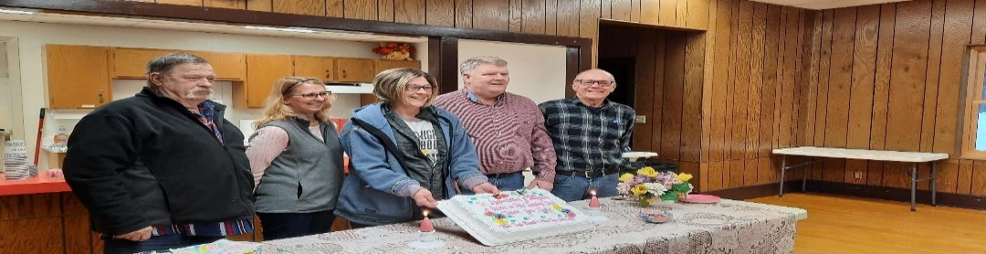

### ARROWHEAD BOOKMOBILE

Hwy 21 and Hwy 135

The Bookmobile offers print books, cookbooks, large print books, DVDs, audiobooks and video games. For further information on the Bookmobile or Mail-A-Book services, contact the Arrowhead Library System, 5528 Emerald Ave., Mt. Iron, MN 55768, 218-741-3840, see us on Facebook or check our web site at [www.alslib.info.](http://www.alslib.info/)

### BABBITT PUBLIC LIBRARY

**Monday-Friday 10:00 am – 6:00 pm**

Check out the Babbitt library Facebook page or babbitlibrary.blogspot.com for upcoming events.

* Babbitt Library Facebook
* Preschool Story Time - Monday's
* Adult Book Talk - Tuesday's
* Young Adult Book Talk - Wednesday's
* Children's Take & Make Kits every mon

### 

**Waasa Township**

**3795 Highway 21, Embarrass, MN**

**Wednesday, March 1, 2023**

**7:00 p.m.**

**Board Members Present:**  Mike Johnson, Carrie Westvik, Kim Daugherty and Sandra Gibson

**Absent:** Supervisor, Steve Sipola

**Visitors:** Don Taylor

Meeting was called to order at 7 p.m. by Board Chair, Mike Johnson and followed by the Pledge of Allegiance.

**Minutes Approval:**  *Mike moved to approve the February 8, 2023 Regular Meeting Minutes after two minor corrections were made. Carrie supported. Carried.*

**Treasurer’s Report:** Receipts received by the March 1st meeting were $2,856.77 from St. Louis County 2022 Town Road Aid and $9,735.00 from St. Louis County, Taconite Production Tax 2023 Distribution. *Carrie moved to approve the Treasurer’s report and Mike supported*. Carried.

**Approval to Pay Bills:** *Mike moved to approve payment of the bills listed below plus payroll and PERA with support from Carrie. Carried.*

**Claims:**

Gibson, Sandra $ 258.39 Treas. Asus Computer & Ink Cart.

Lake Country Power 97.01 Electricity for Town Hall

Menards 13.99 (1) pkg. LED Bulbs for Hall

**Visitor In-Put:** Don Taylor was present to explain his proposal to install new windows in the hall. His price estimate does not reflect the change in pricing of the Marvin windows. Marvin will be increasing their price by 9% March 6th. Since the board isn’t ready to make a decision tonight, Mr. Taylor will provide an updated price. He believes Marvin windows are a better quality window made of fiberglass, as opposed to the other option, being the Jeld-Wen from Menards. He expects, once started, the job would take about 2 weeks to complete.

**Road Report:** No report.

**Cemetery:** Carrie continues to work on records. She has begun to add photos of footstones.

**Old Business:** The 2024 levy was discussed. There will be a 3% increase in the fire contract for next year. The increase would amount to approximately an additional $663.70.

*Motion made by Mike to recommend the following levy for 2024:* **General Fund**: **$15,000.00**

**Road & Bridge: 8,000.00**

**Fire Fund: 22,800.00**

**Total Recommended Levy: $45,800.00**

Waasa’s Local Board of Appeal & Equalization at this time is tentatively scheduled for April 25, 2023 at 4-5 p.m.

It was decided that no action needs to be taken on the CD that is maturing on 3/12/23 at the Embarrass Federal Credit Union.

**New Business:** The clerk reported there was a faucet dripping problem with water collecting in the woman’s bathroom sink but, now seems to be draining.

**Correspondence:** All mail was read and filed.

**Adjournment:** *Mike moved to close the meeting at 8:00 p.m. and was supported by Carrie.*

Respectfully Submitted,

Sandra Gibson, Waasa Town Clerk Mike Johnson, Waasa Board Chair.

*Volunteers Needed!*

**Waasa Cemetery**

**Clean-up Day**

**Saturday, May 20th**

**Starting at 10:00a.m.**

*Please bring a rake. Trash bags will be provided.*

**

Residents have been asked to be responsible for their

loved one’s gravesite.

*Questions? Call 218-290-9290*

**Town of Embarrass**

**LBAE**

**Important Information Regarding Property Assessments**

***The Board of Appeal and Equalization for Embarrass Township will meet on May 2nd, 6p.m. - 7p.m., at Embarrass Town Hall, 7503 Levander Road.*** The purpose of this meeting is to determine whether property in the jurisdiction has been properly valued and classified by the assessor.

If you believe the value or classification of your property is incorrect, please contact your assessor’s office to discuss your concerns. If you disagree with the valuation or classification after discussing it with your assessor, you may appear before the local Board of Appeal and Equalization. The board will review your assessments and may make corrections as needed. Generally, you must appeal to the local board before appealing to the county board of appeal and equalization.

***WELCOME TO OUR NEW EMBARRASS CEMETERY SEXTON, ERIC GARMAN***

**Embarrass Memorial Service**

**  
May 29, 2023, 9:00 A.M.**

**REMEMBER AND HONOR OUR VETERANS!**



***Initial Embarrass Quilt Group Gathering Tuesdsy, May 9, at 6:00 pm at Town Hall, 7503 Levander Road,Embarrass, Minnesota.  Spread the word!  Quilters unite.  See you there!  Questions?  Call Shireen Lee 218-780-4945 or Lex McDonald 218-410-3861.***

***Paper Quilling Take & Create Art Kits***

This program,sponsored by Arrowhead Library System, was funded in part or in whole with money from Minnesota's Arts and Cultural Heritage Fund.

Mountain Iron, MN, *April 18, 2023* ─ The Arrowhead Library System (ALS) will be providing Paper Quilling Take & Create Art Kits to member public libraries to distribute May 1-31, 2023. This art experience has been designed by the Duluth Folk School. Create anything from animals to flowers, mosaics, or fun patterns that you can make into a card or wall art! Participants will start with colorful, pre-cut paper strips which will be rolled into coils using a quilling tool, then learn how to pinch them into a variety of shapes that can be combined to create a unique design. Kits will be distributed at libraries at areas including

Aurora Public Library  
Babbitt Public Library  
Baudette Public Library  
Bovey Public Library  
Carlton Area Public Library  
Cook Public Library  
Duluth Public Library  
Ely Public Library  
Eveleth Public Library  
Gilbert Public Library  
Hibbing Public Library  
Hoyt Lakes Public Library  
Mountain Iron Public Library

Virginia Public Library

**

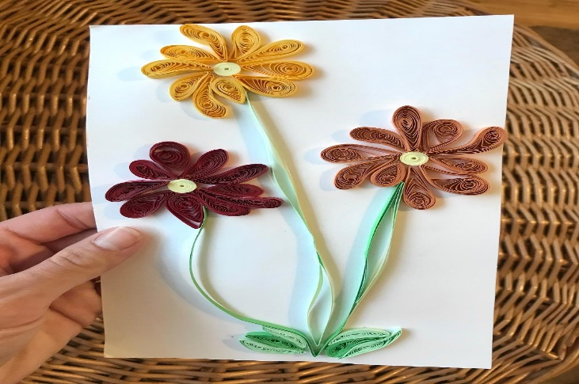

Arrowhead Library System Bookmobile  
Arrowhead Library System Mail-A-Book (*patrons must qualify for Mail-A-Book services, kit may be modified in order to deliver by mail)

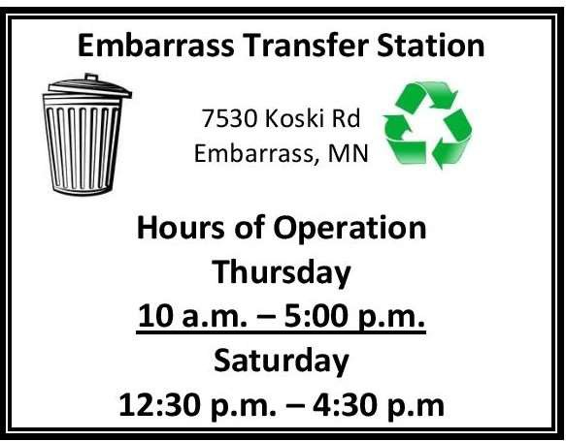





January Minutes were published in April ‘s Fl Flying Finn by mistake.

See March minutes below.

## Sisu Heritage, Inc.

### SISU Heritage Monthly Mtg. March 2023 Present: Marlin Bjornrud, Cindy Scherer, Linda Koskela, David Pike, Tom Sheehan, Mickey White Guests: Roberta Pike, Paul Knuti

### The January minutes were reviewed and approved with no corrections. A copy of the February Annual Meeting minutes was also distributed to board members.

### Cindy presented the January and February financial reports. Tom S. made a motion to accept both financial reports, second David P., Motion Carried

### Mickey W. registered four new members at the Annual Meeting. Membership increased to 155 - 32 lifetime.

### Paul K. reported that after the second phase of the Apostolic Lutheran Church is put on the National Registry it goes to the Department of Interior for final approval.

### A pre-application by May is to be finalized for a restoration /engineering /and architecture grant on the Seitaniemi Housebarn.

### A repair or a new flag pole for the Finnish flag at the Nelimark will be addressed by the SISU Heritage, Inc..

### Tom S. was given the go ahead to purchase a new lock for the main door at the Nelimark and for mouse traps. He will also get price comparisons to purchase a vacuum cleaner.

### *Three concerts sponsored by SISU SISU Heritage, Inc. have been confirmed:*

### * Don & Bonnie Guttormson - Sunday May 21 - Apostolic Lutheran Church

### *Amanda Rae - Saturday June l0 - National Sauna Day

### *Big T and the Growlers - Sunday Sept. 10 - Community Night Out Hanka Housebarn Roof project update: Jake Jankowski has a sawmill were we can purchase tamarack rough cut material for use as nailers. We have to wait till the snow melts to begin the repair on the roof.

### National Sauna Day is Saturday, June 10, 2023 - ( 9:00 am.- 4:00 pm.)

### The board began the planning, duty assignments and will finalize the schedule at April's meeting.

### Submitted by Secretary, Linda Koskela

### Next meeting is Monday, April 17, 2023 @Embarrass Town Hall

### April 2023 SISU Present: Marlin Bjornrud, Tom Sheehan, John Kinnunen, David Pike, Linda Koskela, Pat Heikkila, Ron Sutton, Mickey White, Cindy Scherer

### Guest: Roberta Pike

### 1.April's minutes were reviewed and accepted with a correction in spelling of where in place of (were) in #7.

2.Financial report for April was accepted with a motion by John K., second Pat H.

3.Membership remains the same. 155 – 32 lifetime.

4. Ron S. & John K reported on the progress of two Sauna Tour meetings. A list of (9-10) people have shown interest in leading sauna tours this summer. Tours could begin as soon as June. Further details on chosen sites, advertising and sponsors will be finalized at future meetings. Purchasing a prepay cell phone for use at the Nelimark is under consideration.

5.In preparation of the ***Don & Bonnie Guttormson Concert at the historic Embarrass Apostolic Lutheran Church***

***on Sunday, May 21st @ 3:00 pm.,*** a cleaning day on Friday, 19th at 10 am. Is scheduled at the church. ***Tickets are***

***$10. /children under 12 Free.*** Water bottles will be provided.

6. The board member responsibilities for the National Sauna Day on Saturday, June 10, 2023, at the Nelimark

Farmstead were finalized.

7. Mickey W. SISU representative for the Historical Society reported there will be an increase in the amount of

money allotted to affiliates. Also, by law, the Annual Audits cannot be changed by the Historical Society.

Submitted by Linda Koskela, Secretary

Next meeting is Monday, May 15, 2023 @ 6:30 pm.

**Sisu Heritage, Inc.**

**presents**

Don & Bonnie Guttormson in Concert

Sunday,

May 21 ~ 3 p.m.

Finnish Apostolic Lutheran Church 5083 Hwy 21 in Embarrass

$10 admission ~ children under 12 FREE

Playing together since the 1970s ~ Americana, country, bluegrass, light pop

**Generously sponsored by**

**Knuti Farm of Embarrass**

Diane Nelmark was injured in a car accident on April 20th. Although she is recovering the community is planning a fundraiser sometime in June to help defray expenses associated with her recovery. If you are interested in helping, please contact Jennifer Boese at (218)-984-2084

GET WELL DIANE!

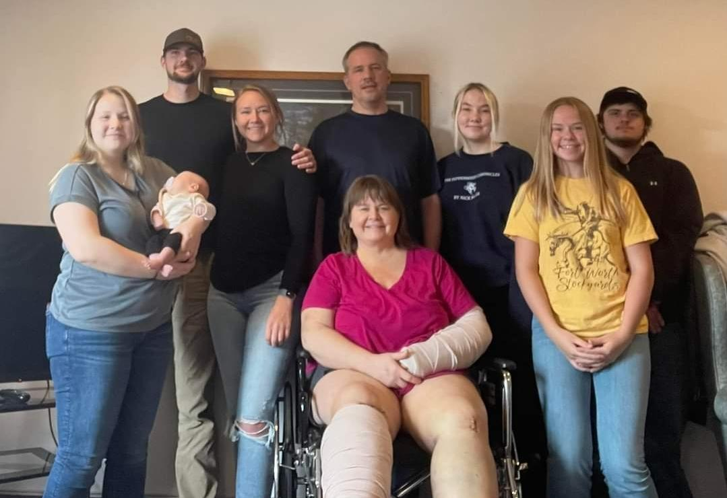



**\*\*\* OBITUARY \*\*\***

**Patricia Mason**

Patricia “Pat” Griffis Waisanen Mason made her final boarding call and “slipped the surly bonds of earth” on Feb. 15, 2023. She died at home in Albany, Ore., with her co-pilot and husband Bill Mason by her side. Over the last six years he walked each step of the “long goodbye” with her, lovingly caring for her until the end.

Pat had many roles in her life. She was an RN, Nurse Practitioner, MSW Counselor and Hospice Social Worker. She was also a wife, mother and grandmother. While in high school, she met and married George Waisanen. Over the next 21 years, they raised five children on the farm in Embarrass. She is survived by four of those children, Candace Dale, George Curtis Waisanen (Jill), James Waisanen (Wendy) and Holly Waisanen. She was predeceased by her daughter, Valerie. She is also survived by her three brothers, Donald, Harold (Dick) and Curtis Griffis, all of Montana.

She is survived by and will be missed by her seven grandchildren and six great-grandchildren. She passed on the value of a good prank to her grandchildren, who learned to check their beds for “short sheets” or “cereal” if Gramma was visiting. They grew up looking to the sky when a plane passed over, hoping Gramma was back.

Pat was an adventurer and lived the adage, “Life is not a spectator sport!” She became a private pilot in her 40’s and spent the rest of her life having fun while checking off items on her bucket list. They included piloting her plane into Oshkosh for the annual fly-in, joining a mariachi band when possible, and spending most weekends at fly-ins all over the south. In 1995, she fulfilled a dream to see Alaska from a single-engine plane. She piloted her Cessna from Texas to Arizona, up the coast of California, to Oregon where she picked up her co-pilot Bill Mason. They explored Alaska together and were married upon their return to Minnesota. Pat and Bill spent the next 27 years traveling the USA and Mexico in airplanes they built together.

It was during her years as a Hospice Social Worker in Texas that Pat met many military pilots. Most of them had walked away after the war, never having the opportunity to fly again in the planes they piloted with such heroism. Pat started the “One More Flight”

program in Rockport, Texas. She arranged for veterans to get a last flight in the plane they piloted whether it be a B17 or a Huey. She was recognized as the Hospice Social Worker of the year for the Texas-New Mexico Hospice Association in part for this program.

Pat and Bill retired to Oregon where they continued to build airplanes and explore the west coast. Together they flew to visit children and friends around the USA and Mexico until she was 80 years young. Pat enjoyed a good laugh and good story. Her family invites you to join them for both at a Celebration of Pat’s Life on Sunday, July 16 from noon to 3 p.m. at Embarrass Town Hall. In lieu of flowers, the family would appreciate donations to the hospice of your choice.

**Top of Form**

**Bottom of Form**

**Viola I. Hollenbeck, 93**

Viola “Vi” Irene Hollenbeck, 93, of Aurora, died on March 25, 2023, at Carefree Living in Aurora. A prayer service was held on April 17 at Ziemer-Moeglein-Shatava Funeral Home in Aurora led by Pastor Barbara Hegfors. Inurnment will be in the Waasa Cemetery in Embarrass at a later date. Memorials are preferred.

Vi was born on March 6, 1930, to R.C. and Cora (Kolle) Eidal. She graduated from Elbow Lake High School in 1948. On Jan. 29, 1949, she married Dick Henry Hollenbeck. The two of them had been married for 62 years. They moved to the Aurora in 1956. In 1957, they moved to Embarrass where they lived for over forty years. They returned to Aurora in the 1990s after their retirement.

Vi was a bookkeeper for North Star Auction for 20 years. She was a lifetime member of the American Legion Auxiliary. She attended the Methodist Church of Aurora and was part of several coffee clubs. She also enjoyed dancing with Dick throughout her life.

Vi is survived by her children, Diane (Bob) Gihl of Shoreview, Peggy Koivisto of Pequot Lakes and Rob Hollenbeck of Dallas, Texas; seven grandchildren, Robert, Scott, Tom, Sue, Ted, Tarik and Tracy; several great-grandchildren; two great-great-grandchildren; five siblings; and numerous nieces and nephews.

She was preceded in death by her husband, Dick; daughter, Teresa;parents; and three siblings.

**David T. Durrant, 78**

David Trayton Durrant, 78, of Tower, died on March 21, 2023, in Waterview Woods Care Center. A celebration of life was held at the Vermilion Club on April 15. Inurnment will take place in the Minnesota Veterans Cemetery in Duluth.

David was born on Nov. 28, 1944, in Virginia, the son of Leonard and Daisy (Walkema) Durrant. He was a veteran of the United States Navy, serving aboard the USS Bennington. After the service, Dave lived out East, in Texas, and was a longtime Tower-Lake Vermilion resident. He was a volunteer firefighter, traveled to the Soviet Union as a wood consultant, and had managed the Cook Airport. Dave was a member of the DAV Kolstad Chapter 23 of Virginia, the Cook VFW Post 1757, and attended the Unitarian Church.

Dave is survived by his wife, Vicki Hall; brothers, Paul Durrant of Minneapolis and Steve (Chris) Durrant of Seattle, Wash.; stepsons, Lorn (Scarlett) Koski of Tower and Lars (Kathryn) Koski of Embarrass; grandchildren, Detton, Darrin, Hunter, Calvin, Parker,Evan, Vince, Lila and Chloe; great-grandchildren, Axel, Amelia, Zoey and Paisley; niece,Jessie Durrant; nephews, Ben and Peter Durrant; grand-nieces and grand-nephews; extended family and friends.He was preceded in death by his parents.

**Darlene Catharine Schroeder, 90**, of Embarrass, MN, died peacefully on Friday, April 7, 2023, at her home with her family surrounding her always in all ways of love.

Darlene was born January 11, 1933, to Alice and Martin Johnson in Foley Village in Benton County, MN. She attended rural school and graduated from Milaca High School, in Milaca, MN. She was a self-taught pianist; she could hear a song one time and was able to play that song. She was the organist for the Ramey Lutheran Church when she was young.

She married her high school sweetheart, the love of her life, Delmer Schroeder on November 6, 1951.

She worked at the Virginia Shirt Factory for many years. She was an active member of the Embarrass Evangelical Lutheran Church and served as the organist for many years. She was a Sunday School teacher, Girl Scout leader, Boy Scout leader and Cub Scout leader. She was always involved with her children’s activities as they were growing up.

She loved music and would play the piano every night and her children would fall asleep to the songs she played. She loved to sew, cook, can, garden, take trips with her husband, family and grandchildren. Camping

and fishing in Canada with her family and grandchildren always brought love to her heart. She was quick witted and could remember everything. She had many friends and family.

Darlene and her husband Delmer raised their children instilling morals, values, wisdom, common sense, respect of others and, more importantly, love. She lived her life honestly, with dignity and strength from her strong faith and trust in God.

She cherished her husband, large family and numerous grandchildren. She was loved by all of her family; they will miss her and see her again in heaven.

Darlene is survived by her daughter, Robin Ramquist, Britt, MN; Robert Schroeder, Embarrass, MN; Rebecca Semeja, Waconia, MN; Richard Schroeder, Babbitt, MN; Randall (Val) Schroeder, Embarrass, MN; Ramona Skoglund, Roy, UT; and daughter-in-law Loralee Schroeder (Ron), Spring Creek, NV and her many grandchildren whom she loved and adored. Her grandchildren would light up her life and always bring a smile to her face.

She is preceded in death by her husband, Delmer Schroeder; son Ronald Schroeder; parents Alice and Martin Johnson; brothers Daniel Johnson, Ty Johnson, Roy Johnson, Carl Johnson and Harold Johnson; sisters Norma Masica, Ann Kipka and Micky Kujawa (Darlene was the last survivor of her may siblings); sons-in-law Daniel Ramquist, M.D. (Robin); Mark Semeja (Rebecca); former daughter-in-law Sharon Alaspa Schroeder Niemi (Richard); and grandchildren Martin Schroeder and James Roydon Miller.

The family will hold a celebration of life this summer.

#### Embarrass Flower &Garden Club

Monday, May 8, 2023, at 7:00 p.m.

Embarrass Town Hall.

Contact Linda Cox at 218-780-4143 for more information regarding joining or volunteering with the Garden Club.





**Embarrass Region Fair Association Minutes April 20, 2023**

*Pending Approval*

**Present Board:** Gustave Schroeder, Jerry Meier, Janine Patten; **Trustees**: Sue Beaton, Janine Patten, Bonnie Meier

**Proposed Directors:** Zane Beaton, Tana Johnson, Janine Patten, Sarah Wallert-Ramponi, William Ramponi, Carissa Smith, Don Taylor, Preston Tripp

**Public Present:** Charlie Fowler, Ken & Bonnie Overton, Toni Theel, Paul Knuti, Rodney & Chrissy Dale, Jim Hardy, Darwin Salo, Gene Wright, Floyd Joki

**Call to Order.** Gus called the meeting to order at 6:35 pm.Tana volunteered to keep time; Sue volunteered to take minutes.

**Minutes of the March 16 and Feb 16 Meetings.** Minutes were reviewed. Jim moved to accept minutes; Gene seconded. Motion passed.

**Treasurer Report**. Jerry and Janine provided a profit and loss statement and stated that the new board will review the budget. Tana moved to accept the treasurer’s report; Chrissy seconded. Passed unanimously.

**New Board Structure/ New Board of Directors** – Gus stated that this is the 3rd presentation of proposed bylaws. Jim asked that before the vote on the bylaws, that introductions take place. Gus apologized for skipping over introductions and directed everyone to the handout of brief biographies of each proposed director. Each candidate introduced him/herself (named above as Proposed Directors).

An organizational chart showing the current board structure and the proposed perpetuating board structure was reviewed*. Tana moved that we adopt the amendment to the bylaws that includes the revised board structure; Sarah seconded.* The vote carried with one opposed. Gene asked for clarification of what makes a quorum since the board is currently comprised of 8 directors and optimum number is 12. Janine explained per the bylaws, a majority of the number of directors then holding office shall constitute a quorum.

Tana thanked the current board for their past leadership and requested that we take a brief break to cake, coffee, and fellowship.

**Turn meeting over to interim chair**. Janine agreed

to serve as interim chair for the remainder of the meeting.

**Rental and upcoming event updates.** Jerry & Bonnie reported that Timber Hall rentals are typical for this time of the year and posted a list of dates that the Timber Hall and Arena have been reserved. Pancake breakfasts have been well attended and we served 310 in April. The last breakfast of the season is May 6 and will include a blood drive. The Timber Hall will remain open as long as donations are being made. Visit mbc.org to reserve a donation time or email timberhallblooddrive@gmail.com.

**Committee Updates**

**Strategic Planning Committee**. Tana stated that the Strategic Planning committee meets the 2nd Tuesday of the month at 6 pm and new members and visitors are always welcome.

**Grant Committee** Tana reported:

* $1.5 M bonding bill is pending
* $5000 from ARAC is pending
* $1000 from Lake Country Power was received
* $300 from Breitung Township was received
* Natural Harvest has chosen the Embarrass Region Fair Association as the beneficiary of their “Change Within Reach Round-Up” program for the month of July. Shop there and round up to the nearest dollar and those funds will be donated to the Association.
* Other area communities have also stated they will be making contributions.

**Project updates.** Tana reported that doors are scheduled to be installed by the first week of June.

**Volunteer Committee**. Sarah reported that she is researching volunteer sign-up methods and volunteer tracking software.

**Finance Committee** – (Janine & Jerry) Update provided in treasurer’s report.

**Marketing Committee** (needs chair) Carissa shared that she has been working with web site and social media ideas and ways to make sponsorship available.

**Nominating & Governance Committee** – (needs chair) Seeking 4 additional people interested in

becoming a director. Contact Tana Johnson or Janine Patten for more information.

tanajohnson@ymail.com or J9patten@yahoo.com.

**Fair Committee** (Sue & Janine) Update follows.

**Timber Hall Logo**– Sue explained that the Web Site it being developed with two entities in mind; the Fair (3-days in August) and the Timber Hall Event Center. Graphically, it is clear that the Timber Hall needs its own brand/logo separate from the fair. Janine, Carissa, and Sue have reviewed a portfolio and agree. *Sue moved that we approve $600 for Timber Hall brand; Janine seconded. Motion passed unanimously.*

**Website: Timber Hall Event Center/Embarrass Region Fair –** Sue explained how the website will work and asked Fair event chairs to review their content. Changes are due to Sue by Thursday, April 27. Anyone with questions should contact Sue at 218-750-2718; suebeaton922@gmail.com.

Attendees were asked to complete a “point-of-contact” sheet to help create a database and expedite communication. This sheet will be available moving forward to help capture contact information of supporters.

**Fair Finances/Considerations**

* Gus shared that more bands have expressed interest in playing at the Fair. He stated that depending on which bands we select, the weekend band budget may range from $3,200 to $5,500. Tabled.
* Darwin requested $400 for The Class Car Show; his request is included in the budget.
* Jim asked if committees were still allowed to spend up to $300 in preparation for the Fair without getting prior approval. This was tabled for May 18.
* Sue explained the cost of Ax Throwing and the decision was tabled until May 18 meeting.

**Miscellaneous**

* Sue will pursue Dave Iverson to once again serve breakfast and tacos in Timber Hall.
* Jerry stated another grill is needed to serve pancakes.
* The next meeting is May 18 at 6:30 Timber Hall.

**Adjourn**

Janine adjourned the meeting at 8:25 pm.

Respectfully submitted, Sue Beaton

**Welcome Spring Pancake Breakfast**

**Saturday, May 6**

8 to 11 am

Timber Hall 4855 Hwy 21

Join us for all-you-can-eat pancakes, choice of ham or sausage links, fruit cup, juice, a bottomless cup of coffee.

Adults $6, children (6-10 years) $3, and under 5 years FREE.

Memorial Blood Centers will be taking donations during the breakfast. A Huge THANK YOU to everyone who has pre-registered! All of the time slots are FULL!

Sponsored by the Embarrass Region Fair Association.



Meet the New Embarrass Region Fair Directors

Zane Beaton, Tana Johnson,

Janine Patten, Sarah Wallert-Ramponi, William Ramponi, Carissa Smith,

Don Taylor, Preston Tripp



 **WANTED**

**Embarrass Fair**

**Little Miss Queen Candidates**

The Embarrass Region Fair is seeking Little Miss Queen Candidates.

The winner will receive $150.00 cash, runner up $100.00 cash and Miss Congeniality $50.00 cash.

Candidates must be female ages 8 – 13, a student and live in or be affiliated with family members in Aurora, Babbitt, Biwabik, Breiting, Britt, Eagles Nest, Ely, Embarrass, Greenwood, Hoyt Lakes, Kugler, Morse, Fall Lake, Palo, Pike Sandy, Soudan, Tower, Vermillion Lake, Waasa, White, Winton or Wuori.

**Apply deadline date is May 15th.**

For more information please contact:

Toni Theel @ (218)-984-3337

Looking forward to meeting all applicants!



## EVANGELICAL FREE CHURCH



**HOPE LUTHERAN CHURCH**

Evangelical Lutheran Church in America

5088 Hwy 21, PO Box 1076, Embarrass

**Office hours**

Tuesday & Thursday, 4:30 – 7 p.m.

Saturday 10 a.m. – 3 p.m. [hopelutheranembarrass@gmail.com](mailto:hopelutheranembarrass@gmail.com)

218-984-2037

Services begin at 10:30 a.m. Temporary Pastor, Billie Rouse

5606 E Taylor Rd, Embarrass, MN 55732 218-984-3402, [www.efreechurch.com](http://www.efreechurch.com/)

E-mail: [marlinb@efreechurch.com](mailto:marlinb@efreechurch.com)

May Flying Finn: Church Schedule Evangelical Free Church of Embarrass

Sunday Bible classes. 9:00a.m. Sunday Worship Service. 10:00a.m.

Monday Men's Bible study.

7:00p.m.

Wednesday women's Bible study. 9:00a.m.

Wednesday Kids on the Rock.

4:00p.m.

Wednesday ENGAGE youth ministry. 6:30p.m.



Sunday, May 7- Church picnic and highway clean-up. 11:30a.m. Sunday,May 21- Ministries team meetings.11:30a.m.

Saturday, May 27- Men's Breakfast. 8:00a.m.

Sunday messages:

7- "Take Every Thought Captive" 14- "Jealous and Afraid"

21- "A Thorn and Grace"

28- "Preparing For A Third Visit"

## 

|  |  |  |  |  |  |  |
| --- | --- | --- | --- | --- | --- | --- |
| Mar. 26  2/42 | Mar. 27  2/39 | Mar. 28  0/25 | Mar. 29  -1/20  sn .80”  pc .04” | Mar. 30  -10/26 | Mar. 31  -10/39 | April 1  16/41 |
| April 2  **16/40** | April 3  26/40  pc .02”  trace sn | April 4  24/38  pc .02”  trace sn | April 5  20/29  pc .26”  sn .60” | April 6  16/35  pc .05”  sn .50” | April 7  -4/28  trace pc  trace sn | April 8  -5/42 |
| April 9  10/48 | April 10  28/57 | April 11  27/61 | April 12  33/69 | April 13  30/72 | April 14  31/61 | April 15  38/73  trace pc |
| April 16  **26/40**  **pc 1.15”**  **sn .20”** | April 17  24/40  pc .36” | April 18  19/34 | April 19  21/48 | April 20  31/39  pc .20”  sn 1.50” | April 21  27/35  pc .72”  sn 5.60” | **2023** |
|  |  |  |  |  |  |  |
| **2022** |  |  |  |  | April 1  2/35 | April 2  2/46  trace pc  trace sn |
| April 3  18/38  trace pc  trace sn | April 4  18/41  pc .05”  sn .40” | April 5  29/44 | April 6  30/39  pc .35”  sn 1.20” | April 7  29/39  pc .04”  trace sn | April 8  23/30  pc .08”  sn .40” | April 9  12/40 |
| April 10  24/52 | April 11  31/49  pc .10”  snow 1” | April 12  23/57 | April 13  23/46  pc .58”  trace sn | April 14  22/38  pc .39”  sn 2.60” | April 15  14/32  pc .05”  sn .80” | April 16  14/23  pc .01”  sn .40” |
| April 17  11/34 | April 18  15/38  pc .21” sn 2.80” | April 19  15/34  trace pc  trace sn | April 20  13/43 | April 21  32/41  pc .32”  snow 2” | April 22  27/42 | April 23  34/40  pc .25” |
| April 24  37/50  pc .55” | April 25  31/42  pc .22” | April 26  19/31  pc .01” | April 27  10/31 | April 28  10/46 | April 29  27/51  trace pc | April 30  39/51  trace pc |